Sandwich Stoichiometry

- Go to the Pet simulation website:
https://phet.colorado.edu/sims/html/reactants-products-and-leftovers/latest/reactants-products-and-leftovers_en.html
- Select “Sandwiches”
- Select “Cheese” at the top
- Use the arrows to enter the following under reactants on the left (“Before Reaction”):

Part 1. Bread and Cheese (1 pt.)
8 pieces of bread
8 pieces of cheese
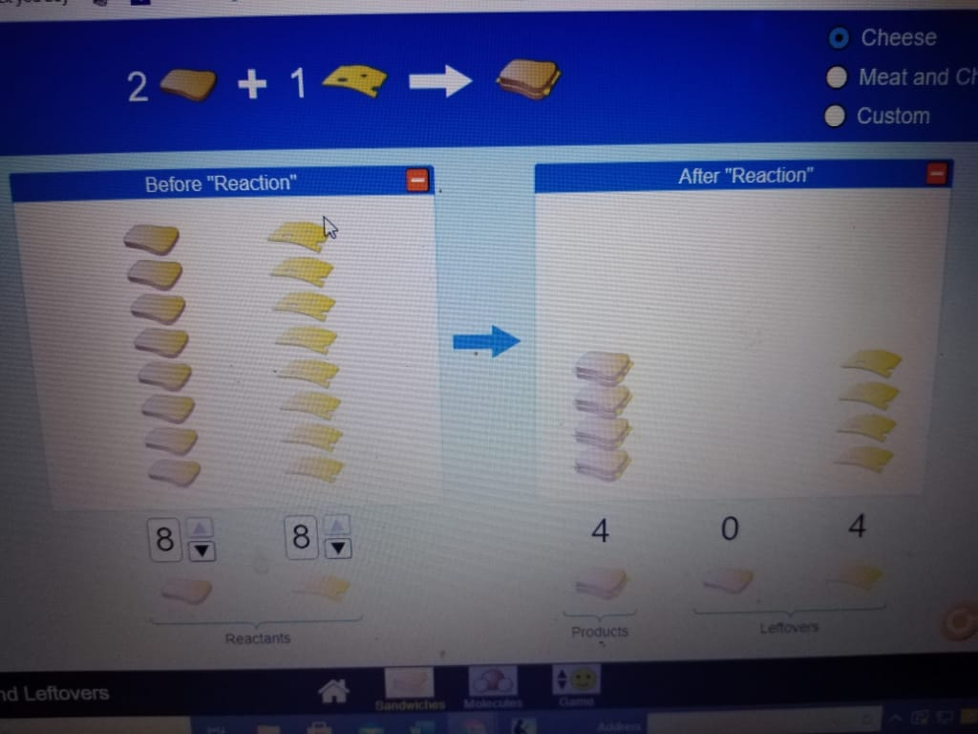

Part II: Meat and Cheese Sandwiches (2 pt.)

Before Reaction
5 pieces of bread
5 pieces of meat
5 pieces of cheese
[Insert the image here]

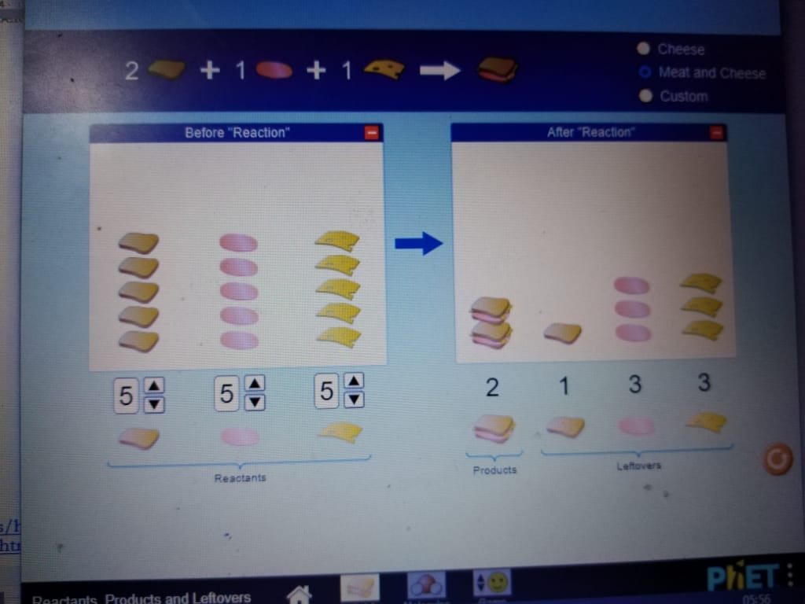

Before Reaction
8 pieces of bread
3 pieces of meat
4 pieces of cheese

\

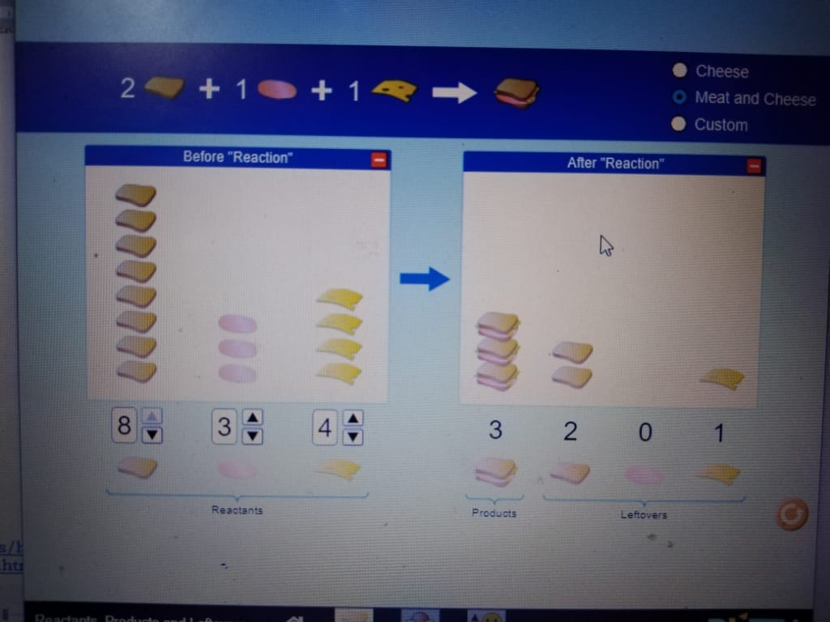[Insert the image here]

Part III: Water (3 pts)

- Go to the Pet simulation website: https://phet.colorado.edu/sims/html/reactants-products-and-leftovers/latest/reactants-products-and-leftovers_en.html
- Select “Molecules”
- Select “Water” at the top
- Use the arrows to enter the following under reactants on the left (“Before Reaction”):

Before Reaction
6 H₂
4 O₂

5. Fill in the number of products and leftovers under “After Reaction” in the table below.
After Reaction | Products | Leftovers
After Reaction | H₂O | H₂ | O₂
# | 6 | 0 | 1

How many H₂ and O₂ molecules do you need to make exactly 4 water molecules with no leftovers?

___4__ H₂ ___2__ O₂

[insert the image here]

Part IV: Ammonia (3 pts)
- Go to the Pet simulation website:
- Select “Molecules”
- Select “Ammonia” at the top
- Use the arrows to enter the following under reactants on the left (“Before Reaction”):

Before Reaction
5 N₂
5 H₂

5. Fill in the number of products and leftovers under “After Reaction” in the table below.
After Reaction | Products | Leftovers
After Reaction | NH₃ | N₂ | H₂
# | 2 | 4 | 2

How many N₂ and H₂ molecules do you need to make exactly 2 ammonia molecules with no leftovers?

____4_ N₂ ____2_ H₂

[insert the image here]

Part V: Methane (3 pts)

- Go to the PhET simulation website: : https://phet.colorado.edu/sims/html/reactants-products-and-leftovers/latest/reactants-products-and-leftovers_en.html
- Select “Molecules”
- Select “Combust Methane” at the top
- Use the arrows to enter the following under reactants on the left (“Before Reaction”):

Before Reaction
6 CH₄
6 O₂

- Fill in the number of products and leftovers under “After Reaction” in the table below.
After Reaction | Products |  | Leftovers
After Reaction | CO₂ | H₂O | CH₄ | O₂
# | 3 | 6 | 3 | 0

How many CH₄ and O₂ molecules do you need to make exactly 1 CO₂ and 2 H₂O molecules with no leftovers?

___1__ CH₄ ___0__ O₂
Now use the ‘Reactants, Products & Leftovers – Game’
[Insert the image here]

Part VI: Game time

- Go to the PhET simulation website: : https://phet.colorado.edu/sims/html/reactants-products-and-leftovers/latest/reactants-products-and-leftovers_en.html
- Select “Game”
- Play Levels 1 first, then level 2, then level 3
HINT: From Level 2 on the counts of products and extras will be much easier to calculate on paper, then you can use the game to check your calculations.

Level 1: You need to score an 8 or better on level 1. Your score: __8____ (4 pts)
Level 1 Problem: (4 pts)
If 5.6 moles Cu are reacted with 7.2 moles of AgNO₃ according to the balanced chemical equation below: YOU MUST SHOW ALL WORK.
Cu (s) + AgNO₃ (aq)​ → Ag (s) + Cu(NO₃​)₂ (aq)​

    - How many moles of Ag can I make?
No of moles of moles of CU = 5.6 moles
Moles ration for Ag and Cu is 1:1
Therefore no. of moles of Ag = 5.6 moles

    - Which reactant is limiting?
5.6 moles of Cu needs 5.6 moles of NaNO₃
The limiting factor is therefore NaNO₃

    - How many moles extra do I have of the reagent in excess?
7.2-5.6 = 1.6 moles

Level 2: You need to score an 8 or better on level 2. Your score: __10____ (5 pts)
Level 2 Problem: (4 pts)
If 18.74 g of P₄ is reacted with 9.6 g of Cl₂ according to the balanced chemical equation below: YO MUST SHOW ALL WORK.
P₄ (s) + 6Cl₂ (g) → 4PCl₃ (l)

- How many grams of PCl₃ can I make?
- No of moles of clorine = 9.6/35.5 = 0.1352
No. of moles of Phosphorous = 18.74/40
=0.4685 moles
No of moles of PCl₃ ( = 0.1352*6/4 = 0.2028 moles
Mass = 0.2028*146.5 = 29.71g
- Which reagent is limiting?
Limiting reagent is chlorine
- If I actually do this in the lab and collect 10.5 grams of PCl3 what is the percent yield for the reaction?
(10.5/25.71 )*100%
= 40.84%

Level 3: You need to score an 8 or better on level 3. Your score: ____9___ (5 pts)
Level 3 Problem: (8 pts)
If 15.6 grams of MnO₂ are reacted with 19.6 g of HCl according to the unbalanced chemical equation below: YOU MUST SHOW ALL WORK.
MnO₂ + 4HCl → MnCl₂ + Cl₂ + 2H₂O

- How many grams of MnCl₂ can I produce? (3 pts)

No of mole of MnO₂ = 15.6/87 = 0.1793moles
No of moles of HCl = 19.6 / 36.5 = 0.5370 moles

Mass of MnCl₂ =0.5370/4 * 126= 16.92g

- Which reagent is limiting? (1 pt)
Limiting reagent is HCl

- How many grams of the reagent in excess will be used and how many grams will be left over? (3 pts)
Excess moles of MnO₂ that reacted = 0.1793/4 = 0.0448moles
Excess moles = 0.1793 – 0.0448 = 0.1345 moles
Excess mass = 0.1345 *87 = 11.70 g

